Assignment-3

**Time Series Econometric Analysis**

BY

**Vikas Sheoran(2018B3A70847H), Manu Priyam Mittal(2018B3A71051H)**

**SUBMITTED IN PARTIAL FULFILLMENT OF THE REQUIREMENTS OF**

**ECON F342 APPLIED ECONOMETRICS**

**BIRLA INSTITUTE OF TECHNOLOGY AND SCIENCE PILANI (RAJASTHAN)**

**HYDERABAD CAMPUS**

**(28th April 2021)**

**ACKNOWLEDGMENT**

We would like to express our sincere gratitude and thanks to Professor Dr Rishi Kumarwho gave us the opportunity to do this econometric analysis on Time Series Data.

# **INTRODUCTION**

Private enterprises play a very important role in the growth of an economy. The growth of these private companies in a country indicates, that there is establishment of well-planned policy structures and also the macroeconomic variables related to the policies. One such variable is interest rate. The objective of the study is to find the effect of interest rate on the Corporate Bond Yields in an economy. The proxy for interest rates is 1-Year Constant Maturity Interest Rate and that for corporate Bond Yield is Moodies Aaa rated Corporate Bond Yields. The data under study is weekly data from 1990-04-06 to 2021-04-02, for USA. The data is taken from [**https://fred.stlouisfed.org**](https://fred.stlouisfed.org)**.** In the first part, ARIMA model is fitted on the Corporate Bond Yield Data. In the second part, ARDL model is fitted to see effect of interest rates on the bond yields.

# Fitting ARIMA MODEL

The data under study is the Moodies Aaa rated Corporate Bond Yield and is named as “Yield.

First of all, the data is imported into R and checked for the following irregularities:

Here is the plot of the original time series:

**FIG_1**

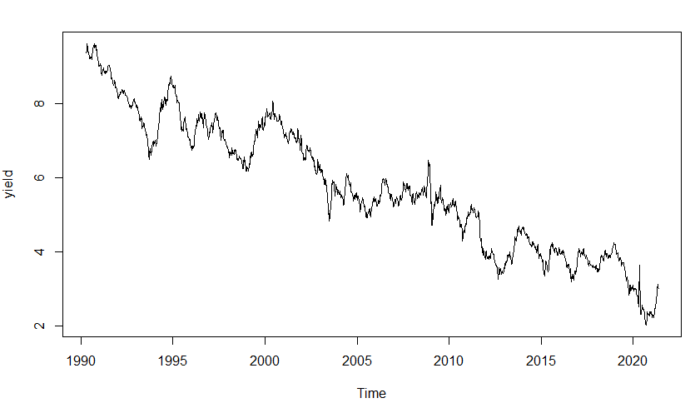

1. Additive/ Multiplicative: The random as well as seasonal components of the original series shown above are roughly constant over time and so we see that the series can be explained using additive model, hence no need for log transformation.
2. Seasonal / Trend/ Irregular components: The series is decomposed using decompose () function and seasonal, trend and irregular components are captured separately, in order to seasonally adjust the series. The components are as shown below. (Trend is automatically removed by first differencing the series for making it stationary.)

**FIG_2**

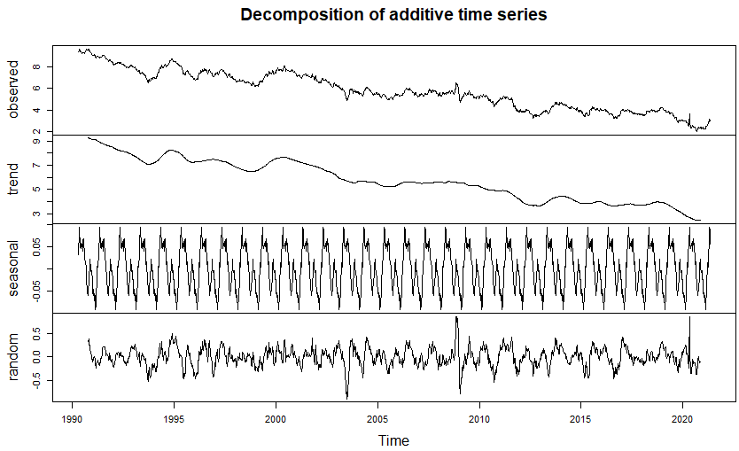

* The Trend Component is also estimated using smoothening technique, by SMA () function of TTR package. The trend is as follows.

**FIG_3**

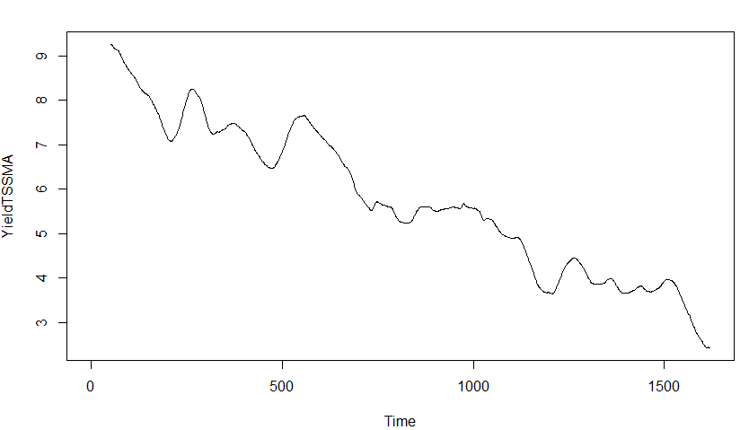

* The series after adjusting for seasonal components.

**FIG_4**

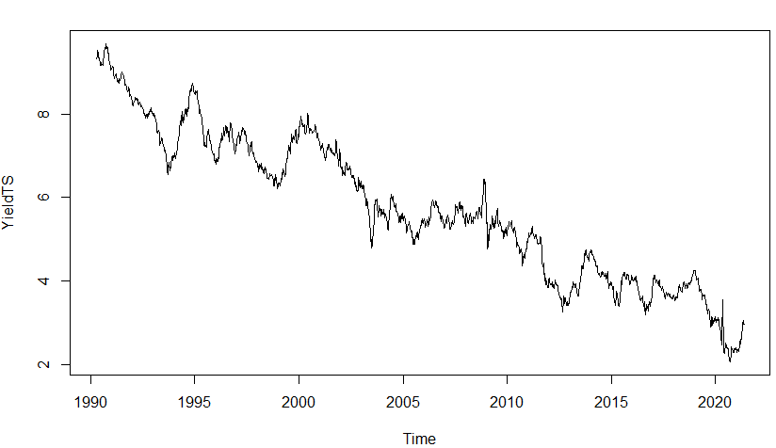

This is the final series that we proceed with for further calculations.

1. **Stationarity:**
2. **Scatter Plot:** From FIG_4, we see that the series has no nature of returning back to the mean, and so we can say from graph, that the series is not stationary.
3. **Formal Test:** **stationary.test** () function is used for this. The null hypothesis for this test is that the series is not stationary. On running the command, p value obtained is greater than alpha at 0.05 significance level, hence null hypothesis is not rejected and the series is not stationary.

**Remedy:** Take first difference of the series using diff () function and then perform the same test.

**On taking first difference of the series, the test gives p value <= 0.**01, hence the null hypothesis is rejected indicating that the difference series has become stationary. Moreover, due to differencing, the trend is also removed from the series, and the difference series is shown.

**FIG_5**

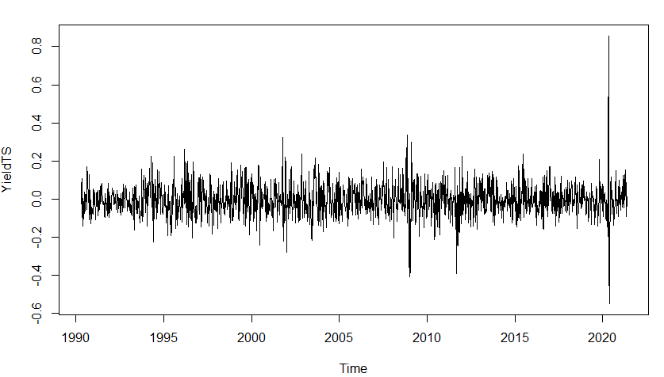

1. **Fitting the model:**
2. **Using ACF, PACF:** The acf and pacf of the differencedseries are plotted as shown. Since the ACF and PACF, both are geometrically declining, we can say that ARMA (p, q) model will be fitted but the value of p and q cannot be predicted directly as there are no significant lags as shown in FIG_6 and FIG_7. Hence go for the formal auto.arima() function.

**FIG_6**

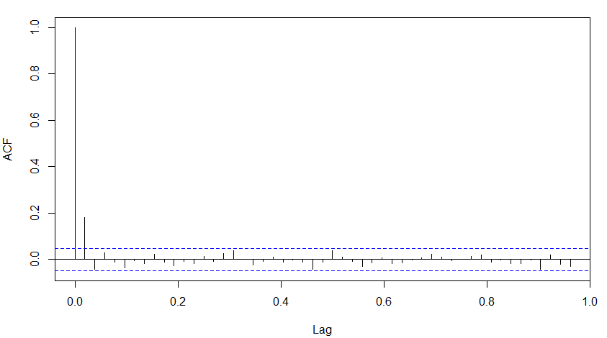**FIG_7**

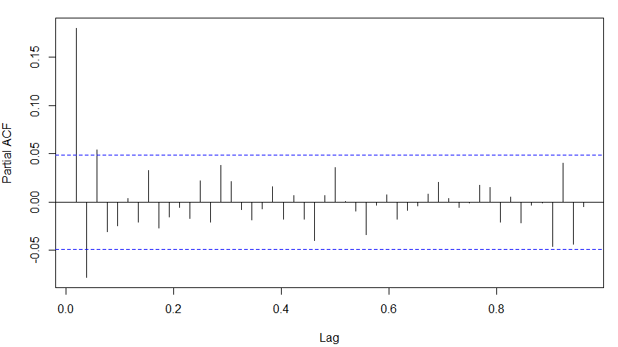

1. **Auto.arima() and Information Criteria:** The function auto. arima is used using AIC and BIC as the information criteria. AIC suggests ARIMA (0,0,2) on the differenced series and BIC suggests ARIMA (0,0,1) on the differenced series. Both the models are fitted, however **ARIMA (0,0,1)** on the differenced series is given priority as this is suggested by BIC, and we proceed with it.

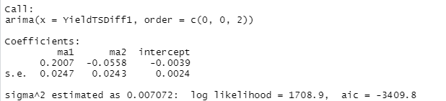

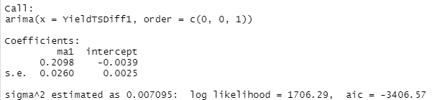

1. **Forecasting:**

The above model, ARIMA (0,0,1) is used further to predict the values of the Yield for 52 periods. The forecast is obtained as point result=0.003648 for the first period and as

-0.0030487 for the rest 51 periods. There is also interval reported at 80% Confidence interval and 95% confidence interval. The values for some periods and plot are shown.

**FIG_8**

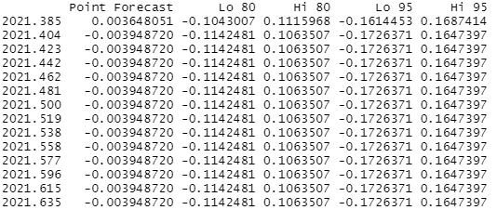

**FIG_9**

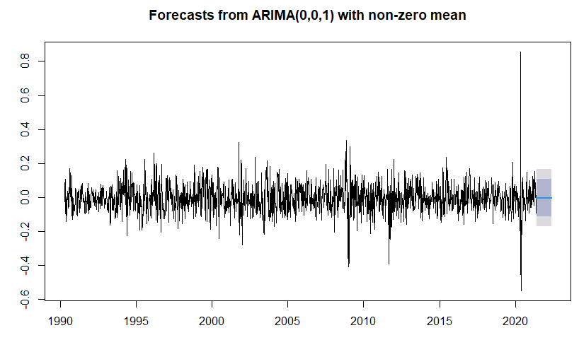

**Comments:** The forecast is obtained using the forecast () function under forecast package. The forecast is done for 52 periods, that is approximately 1 year. We get a positive value for the first period and a negative and also the value with same magnitude for the rest 51 periods. The intervals at 80% and 95% are also the same for the rest 51 periods.

1. **Checking the model:**
2. **Autocorrelation in the residuals:**
3. **Using acf of residuals:** From the acf of residuals of the forecasted values, we can see that there is no significant serial correlation among the residuals.

**FIG_10**

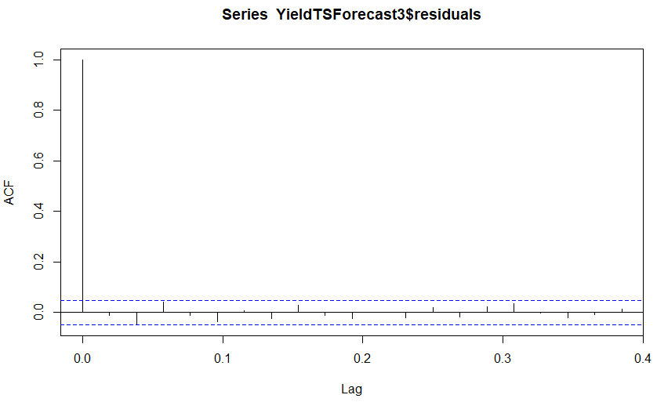

1. **Formal Test: Ljung-Box Test:** The null hypothesis for this test is that there is no serial correlation at any lag. On running the test on residuals, we get p value as 0.9128 > alpha at 0.05 significance level, hence we do not reject null and conclude that there is no autocorrelation in the residuals of the forecasted values.

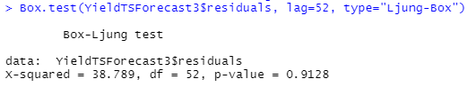

1. **Normality of errors:** We draw a histogram of the residuals and conclude that they follow a normal distribution.

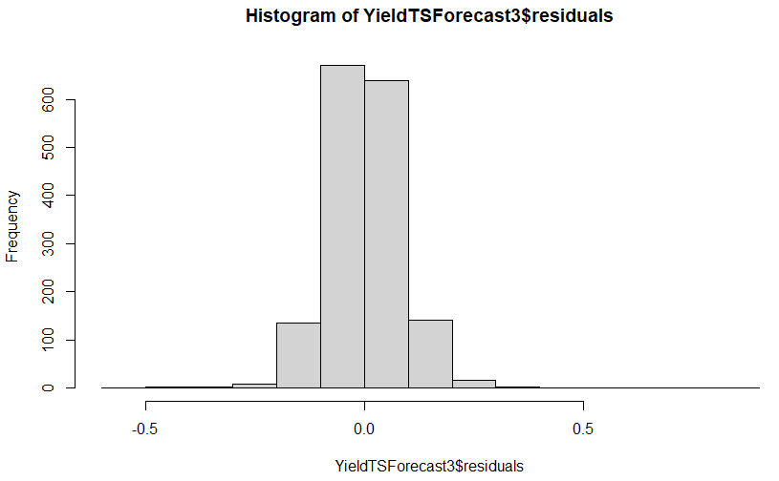

**Hence, we see that the residuals are satisfying the required assumptions.**

**Conclusion:**

BIC as the information criteria suggests ARIMA (0,0,1) on the differenced series and the residuals of the forecasted values also follow the required assumptions, hence ARIMA (0,0,1) is the final model that we fit on the differenced series, and forecasted values are shown in the Forecast section.

# Fitting ARDL

The dependent variable is Moodies Aaa rated corporate bond yield, and the explanatory variable used is 1-year constant maturity rate as proxy for interest rates. The expected relation between the two variables is that of a positive relation, that is, if the interest rate increases, the bond price falls, causing the bond yield to increase. The analysis is done as follows.

1. **Stationarity of both series:** As also discussed in the Part 1 of the assignment, that the yield series was not stationary so was made same by first differencing. The interest rate series is as shown in FIG_11, and comes out to be non-stationary when stationary.test () function is used on it as the p value was greater than alpha at 0.05 significance level, hence it is also made stationary by first differencing and the differenced series is also shown in FIG_12. Further calculations are performed considering the differenced series of both yield and interest rate.

**FIG_11**

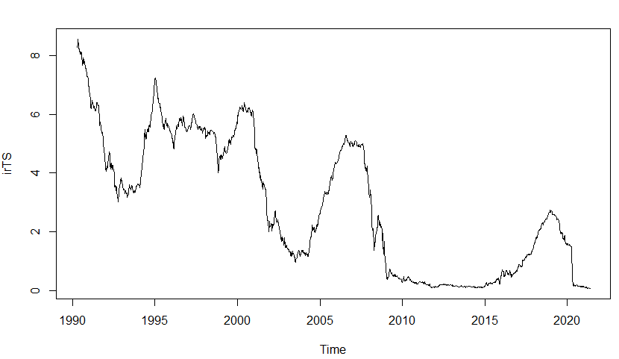

**FIG_12**

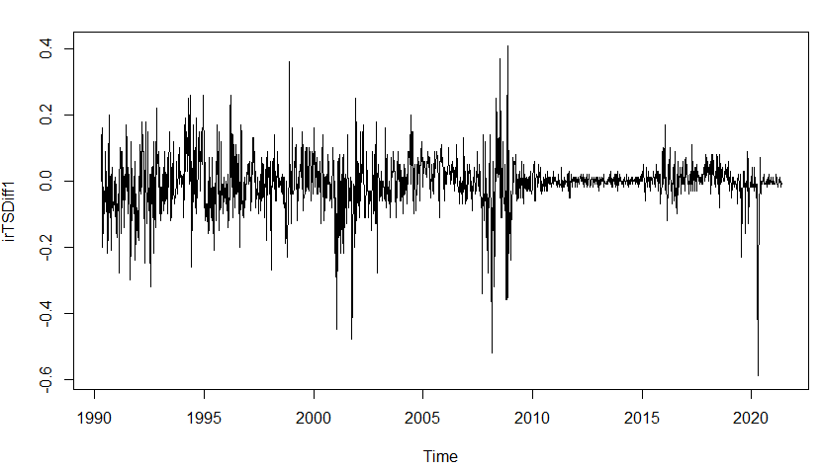

After this, the data is brought in proper format using the cbind () and kable () functions.

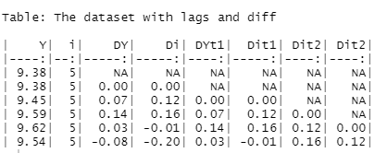

1. **Fitting FDL Model:**

Several FDL models are tried to fit in like FDL (1), FDL (2), FDL (3), FDL (4), however following are the results obtained based on the three criteria.

1. **Coefficient’s sign:** Based on this method, FDL with zero lags of the interest rate was being suggested, as we expect positive relation between the dependent and independent variable, and only in FDL with lag 0, expected sign was observed. After lag 0, all lags that were checked had negative sign. But we see that the coefficient of lag 1 is also significant and if supported by information criteria, we can include this lag also in our model as the net effect of change in interest rate after 1 time period that is in the next time period is positive. (0.4315-0.0749=0.3566)

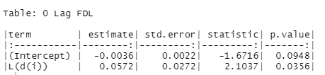

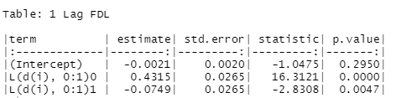

1. **Significance of coefficient:** Based on this method, FDL with lag 0 was suggested with significant coefficient, and also FDL with order 1 and 2 were also suggested. After that the coefficients of further lags were insignificant, though at lag 4 also the coefficient had positive sign as expected. Hence FDL (0), FDL (1), FDL (2) is suggested using this method.
2. **Information Criteria:** From AIC, BIC, we see that FDL (1) is supported as the BIC value is minimum for FDL (1) and we also saw this using the expected signs.

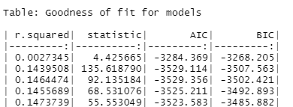

Hence, from the three criteria used above, we can conclude that FDL (1) is the fitted model.

**Interpretation of the result**: From the Table 1 Lag FDL given above,

The interim multiplier that gives the effect of a sustained increase in the interest rate of 1% is, 0.4315-0.0749=0.3566% increase in the bond yield for 1 period that is 1 week.

Also, an increase of 1% in the interest rate causes bond yield to increase by 0.4315% in the current period and causes to decrease by 0.0749% in the next period.

1. **Testing for autocorrelation in the residuals:**
2. **Scatter Plots:** The scatter plot of residuals is as shown in FIG_13. From the figure we can say that some patterns do exist in the residuals, increasing values are followed by increasing values and decreasing values are followed by decreasing values, so autocorrelation exists by seeing the scatter plot.

**FIG_13**

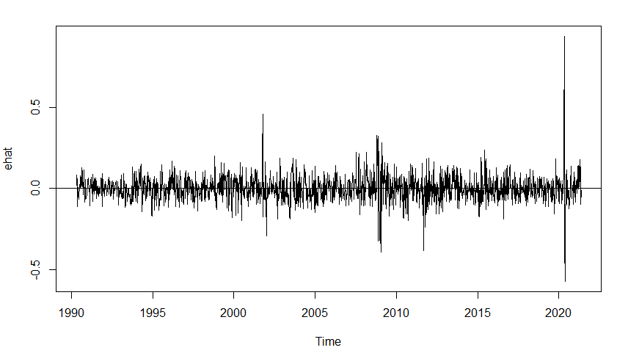

1. **Correlogram:** From the acf of the residuals also we see that there is a spike, hence significant autocorrelation exists in the residuals.

**FIG_14**

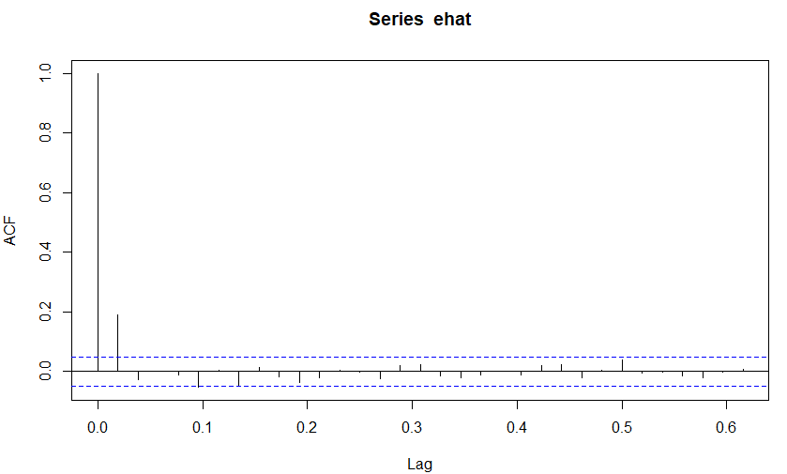

1. **LM Test:** The test is explained as follows. For a model fitted as Y=b1+b2Xt+et, and et=pet-1+vt, we can find the model, et^ = a1+a2xt+pet-1^ + vt, and we perform the lm test with the null hypothesis that p=0, that is there is no autocorrelation in the residuals. In R, this can be done using bgtest () function, by giving the e0^ value as either 0 or by eliminating it from the model. The result obtained on performing the test is that p value obtained are smaller than alpha at 0.05 significance level and so we reject null and **conclude that there is autocorrelation in the residuals**. The result is shown:

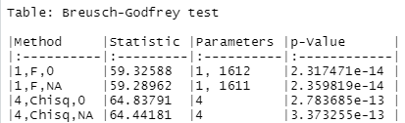

1. **Durbin Watson Test:** This test is also used to check for autocorrelation in the residuals. It also results in rejection of the null hypothesis that there is no autocorrelation, hence conclusion is that serial correlation exists.
2. **ARDL Model:**

**Steps:**

From the result obtained in the above figure, we see that there is autocorrelation in the residuals, and hence we need to modify the model by adding the autoregressive terms in the model.

Several models are fitted like ARDL (1,1), ARDL (2,1) ARDL (3,1) but we see that from ARDL (3,1) the lags of autoregressive terms become insignificant. Hence, ARDL (1,1), ARDL (2,1) are suggested using significance of coefficients.

To get the result formally, Information criteria is used and it also suggests ARDL (1,1) as BIC is preferred over AIC and BIC value is minimum for **ARDL (1,1).**

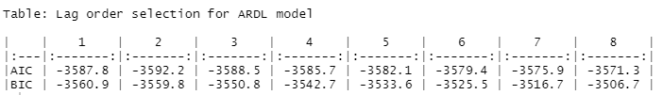

Hence the results from ARDL (1,1) are as shown:

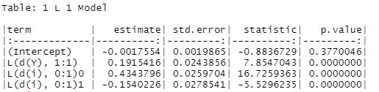

**Interpretation of results/ Conclusion from the ARDL (1,1) Model:**

From the table above we see that an increase in the bond yield by 1% causes the bond yield to increase by 0.192% in next period. Also, an increase in the interest rate by 1% causes the bond yield to increase by 0.4344% in the current period and by 0.2803% in 1 period that is by next period.

1. **Forecasting:**

The values of bond yield are forecasted for next 5 periods. This is done using the forecast () function in R. However, we also need the forecasted values of the differenced series of the explanatory variable as it was differenced to make it stationary and is now required to forecast the values of bond yield. ARIMA (2,1,0) is fitted on the interest rate series after removing the seasonal component and also smoothening the series using SMA () function.



The above figure shows the forecasted values of the differenced series of interest rate. This is passed as an argument to forecast the values of bond yield.

The figure below shows the finally forecasted values reported as lower and higher bound at 95% Confidence Interval, and also the point forecast.

